Chapter 9

Four steps to do hypothesis testing:
✶ State your null and alternative. (H₀ and H₁)
✴ Calculate your statistic value. Find your critical value.
→ Use your decision rule. (Compare statistic value and critical value.)
✵ Make your decision.

About , there is a rule of thumb to decide what should be your null, that is, if you see a statement includes an equal sign, take it as your null. For example, if a company wants to test its annual rate of return is at least 10%, then the null is μ≥10%; if the company wants to test its annual rate of return is no less than 10%, then the null should be μ≤10%. (Since you can’t test H₀: μ>10% & H₁: μ≤10%.)

About , again, when you test for population mean, use Z or t; when you test for population variance, use χ² or F. And always remember the condition for using Z or t, it’s whether you know the population variance or not.

About , Look At the Alternative. It will tell you whether it’s a one-sided test or a two-sided test. It will also tell you what should be your decision rule. (About the direction)
For example, if you have H₁: μ<10, assume variance known, then your decision rule will be reject null if Z*<-Z_{α}; if you have H₁: σ²≠σ₀², then your decision rule will be reject null if (n-1)S_{x}²/σ₀²>χ²_{n-1,α/2} or (n-1)S_{x}²/σ₀²>χ²_{n-1,1-α/2}

About , only remember to write down your decision with AT WHICH SIGNIFICENCE LEVEL, if you don’t want to lose points in your exams.

Q.1

Some of you write down decision rule as Z*<1.28. But remember whenever you’re testing the mean, there must be a negative sign following the “<”.

Also someone chooses t value in this question. (Maybe 16 is just too small) But we know population deviation here. That’s Z.

Q. 3

(a) The solution gives null as H₀: μ=3. But I think H₀: μ≤3 is more appropriate here. Anyway, I’ll show you these two are actually identical. (That is, they will give exactly the same conclusions. Or you can say all that matters is just alternative. Since it will tell you the decision rule.)

(b) The problem here is how do you calculate P-value. (Please draw a graph first)
Under one-sided test, P-value=1-F(Z*)
Under two-sided test, P-value=1-F(Z*)+F(-Z*)=1-F(Z*)+[1-F(Z*)]=2[1-F(Z*)]
Notice in two-sided, 1-F(Z*)=F(-Z*) because standard normal distribution is symmetrical around 0.

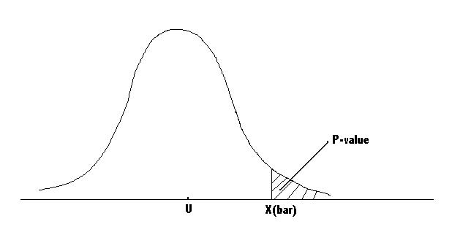
Remember, when you calculate the P-value, you don’t need to know any info about level of significance; you just need to use sample information. (Transform sample mean to standard normal or t.)

(c) Suppose that the alternative hypothesis had been two-sided rather than one-sided, then the P-value will double. Why? Because we still use the same sample, so the Z* will not change. Instead of the formula I use above (actually from these formulae you will know the answer is double), think in this way:
When one-sided, we need Z*≥Z_{α} in order to reject the null. So when α≥1-F(Z*), we reject the null. According to the definition of P-value, 1-F(Z*) is the P-value here. (Since it’s the minimum significance level we can reject the null)
When two-sided, we need Z*≥ Z_{α/2} in order to reject the null. So when α/2 ≥1-F(Z*), we reject the null. That is, α ≥ 2[1-F(Z*)], and still according to the definition of P-value, now 2[1-F(Z*)] is the P-value here, which means P-value will double.

Q. 5

Two Sided, OK? And It’s T. (Don’t tell me you can use Z, I know. Actually you must, cause t-table will not tell you. That’s it.)

Q. 11

You know you should use t, right? But how do you calculate the P-value? The question is you can’t obtain an exact P-value. (At least based on the tables we have) So what you can do is to choose 2 significance levels which with one you can reject, with the other you can accept. That is, you know P-value is between these two values. Anyway, your objective is just to test the company’s claim. That’s enough.

Q.15

- This part is the same as Q. 11. (I mean the way we use to test the company’s claim) Don’t try to find a P-value in the Z table. (Especially when your sample size is less than 30)

- Yes. Just think about the P-value. If the P-value becomes smaller, than we know the company’s claim could be rejected at a lower significance level than in part (a). (Why? Because P-value is the minimum significance level we can reject the null. Just use the minimum)

So CALCULATE THE P-VALUE.

The t statistic value will be larger (I mean the absolute value) and t distribution will become flatter on each side. (Draw a graph will help you thinking) So the P-value should be smaller. But you can check it by getting the exact P-value. (Can you?)

Q. 10 (From Olivia)

- No. What does it mean the null hypothesis is accepted at the 5% significance level? Suppose population variance σ² is known. Then we know Xbar (that is, the sample mean) is less than or equal to μ₀+Z_{.05}σ/√n. Now imaging a sample mean which is extremely small, something like μ₀–1234567, then the 95% confidence interval for μ (using this sample mean) will definitely not contain μ₀ (check it yourself)

- Yes. What does it mean if the observed sample mean is bigger than μ₀? (Draw a graph now!) Now we know Xbar is between μ₀ and μ₀+Z_{.05}σ/√n. So the 90% confidence interval for μ will be (Xbar- Z_{.05}σ/√n, Xbar+ Z_{.05}σ/√n ) Then we know 90% confidence interval for μ must include μ₀ no matter how large Xbar could be. (even if Xbar approach μ₀+Z_{.05}σ/√n) However, you must notice a problem here. Actually Xbar can be μ₀+Z_{.05}σ/√n, then we must require confidence interval be closed, not open, or we could say “NO” to this question. Anyway, generally the closed or open sets are not a big deal in this course.

